**Final Project Report**

**Table of Contents**

1 Introduction 3

1.1 Client’s objectives & brief 3

1.2 Target audience as defined by the client 4

2 Design methods 4

2.1 Responsive web design 4

2.2 Bootstrap 4.1 CSS framework 5

2.3 Scalable Vector Graphics (SVG) 6

3 UX methods 6

3.1 The sample group 6

3.2 Early involvement 7

3.3 The questionnaire 7

3.4 The findings 7

3.4.1 Quantitative results 7

3.4.2 Qualitative results 11

4 Technical details 13

4.1 HTML code 13

4.1.1 Site architecture and prototypes 13

4.1.2 Design decisions 17

4.1.3 Navbar challenges 17

4.2 CSS code 18

4.2.1 Mobile styling challenges and solutions 19

4.3 JavaScript and PHP 20

4.3.1 Show & hide function 20

4.3.2 Challenges with the Skrollr library 20

4.3.3 PHP 21

5 Findings and conclusion 22

5.1 The client 22

5.2 Planning 22

5.3 research 22

5.4 technical findings 22

5.5 Conclusion 23

7 Appendix 24

7.1 Website links 24

7.2 Questionnaire link 24

7.3 Project plan 24

8 References 25

# Introduction

This report will attempt to describe the process of putting a website (Minimal Works - MW) together for a client who has an above average amount of overall digital experience and regularly works with developers, digital publishing specialists and product owners to train them, how to optimise the product development method. As the client’s requirements are highly specific and technically detailed, the second objective of this essay is to demonstrate the challenges of developing for a technologically expert client.

## Client’s objectives & brief

Initially the client has set seven main criteria that provided the foundation of the concept – He wanted a minimalistic, light-weight, clutter-free portfolio website that works responsively on tablets, phones and desktop computers, shows all the required content, is easily customisable by the owner after launch, search-engine optimised, is well documented and it is worth visiting again to see new content. We have set up a product backlog to record and follow up these requirements.

1. **Minimalistic, light-weight, clutter-free portfolio website**

The client only provided pointers towards the design of the website without specific examples. Instructed me not to use harsh bright colours, only use one key colour and that I should add the colour values to variables, so it can be changed later on easily. Creating a light-weight site that is quick and has not much content or large bitmaps/animations to download was also a crucial point he made.

1. **Responsive and interoperable**

The client’s initial opinion was that the site’s target audience will most likely use a phone or tablet to look at his portfolio, thus he specifically requested to create a responsive site that looks and works the same way on all screen sizes without restrictions. Ensuring that the site will work on all platforms (PC/Mac) and cross-browsers was an important aspect as well.

1. **Shows all the required content**

Content-wise he specified four pages within the website – About me, Portfolio, Blog and Contact, plus one landing page that sets the mood for the visitor. These pages should contain his experience and education in a downloadable form, his work achievements and portfolio and his work-related blogposts that will make visitors come back again.

1. **Customisable**

As the client wants to possibly reuse this design and site in the future on different domains, he needs the developer to create the options to change colours, icons and background graphics easily.

1. **SEO**

A business purpose website needs to be optimised for searchability in order to be found by potential employers or fellow professionals, thus the end product will need to have metatags for each section of each page and proper description in the HTML heads.

1. **Documentation**

The site needs to retain the options to be changed on a higher level (colour palette, icons, backgrounds and animations) which means the owner wants to understand everything in the code. The developer needs to add explaining comments and functions that will provide batch changing options on the site.

1. **Worth visiting again**

The only section that needs to have renewing, dynamic content is the blog page. The client wants to add short articles to this page that can be hidden on demand. The developer needs to create an environment where adding a post is simple enough and the interactive functions (hide, share) will work with the new posts as well.

## Target audience as defined by the client

The client has created a list of professionals who would be interested to see his professional website and also be inspired to read his professional thoughts on SCRUM and Agile. The list contains future clients, fellow SCRUM Masters, colleagues, who are currently being trained by the client, HR advisors and recruiting agents, who might offer him new opportunities.

A short Survey Monkey questionnaire was sent out to people on this list to find out their expectations towards such a website both technically and content-wise and to ask for their opinion about the design of an early prototype that was put together in Adobe XD.

# Design methods

## Responsive web design

Years ago, there was a common approach to designing webpages for different screen sizes – namely by defining a minimum target resolution for the browsers and then creating a fixed-width design on this size. However, with a changing mobile device market the web design industry had to adapt. According to Google's research of users’ expectations and reactions about their mobile website experiences, “52% of the users said that a bad mobile experience made them less likely to engage with a company” (Fisch, 2012).

The phrase "responsive web design" was first used by a web designer (Marcotte 2010). It is a method that suggests that design and development should react to the user’s behaviour and environment based on screen resolution, platform and orientation by using a fluid layout grid, flexible images and media queries available in CSS3.

As the client requested the *MW* site should be responsive by all means – from the navigation bar to the whole layout and imagery. This was one of the reasons I chose the Bootstrap library, which provides easy implementation for the CSS3 media queries necessary for the site, also has a pre-set navbar function which works perfectly on every mobile platform. Apart from saving a significant amount of time this solution has the benefit of working not only on every platform but on every type and age browsers.

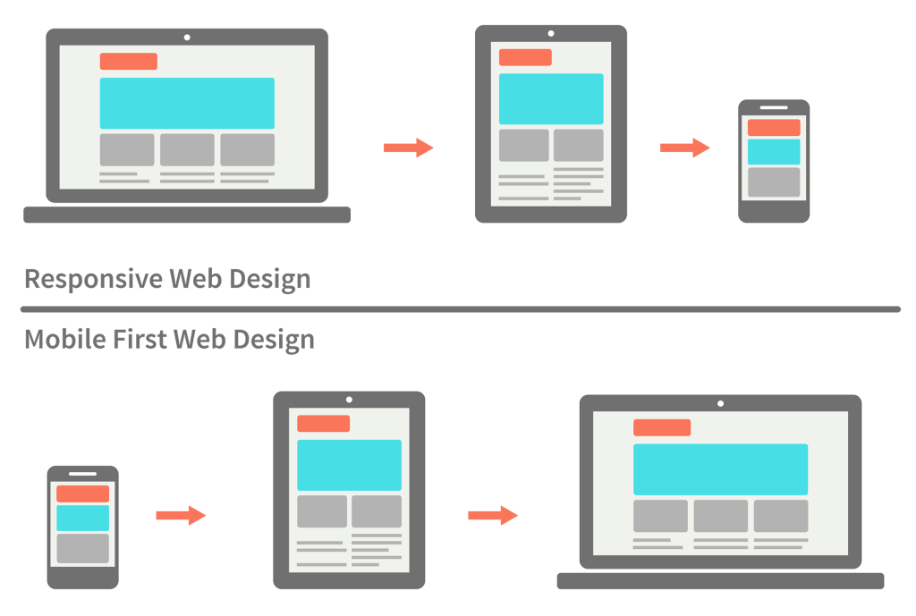From the two types of responsive approaches – ‘mobile-first’ and ‘desktop-first’ – my client advised to prefer the mobile one – simply because of his target audience scope. However, as a designer/developer I had to go against his indication since given the limited timeframe and resources an optimal solution had to be found. According to Gonzalo (2017) mobile-first strategy is only favourable when we have a “carefully analyzed and structured” prepared content that can be presented in an extending manner on increasing screen sizes. It also requires longer time, higher budget and an experienced team – as these options were not available and my client could not provide me a prepared content in time, I had to choose the traditional way of creating a desktop design and scale it down and “degrade it gracefully” (Gonzalo, 2017).

## Bootstrap 4.1 CSS framework

A front-end framework is a standardized set of concepts, practices and criteria for dealing with a common type of problem (Jain, 2014). According to his study, a web designer ought to choose a framework based on several properties – ease of understanding, long-term support and speed of installation and setup – and to these standards Bootstrap stands up without a problem. Its popularity ensures that it is going to be supported for an extensive time, with lots of third-party plugins and extensions, its structural design and clean code provides easy understandability which is important for my client. All in all, Bootstrap is “undisputed leader among the available frameworks today” but the main reason I recommended Bootstrap for my client is that currently it is the most popular and well-established responsive and interoperable framework on the web, that can behave dependably on every platform and mobile screen-size.

## Scalable Vector Graphics (SVG)

SVGs are an “XML based markup that can contain two-dimensional vectors” – in other words “they can look crisp at all screen resolutions, can have super small file sizes, and can be easily edited and modified”. (Giltsoff, 2015) The idea of utilising SVGs on the *MW* website came up when the client mentioned that he might want to change the illustrations/icons (size, stroke and fill colours, background, etc.) later effortlessly all at once. Simplistic, minimalist design and a light-weight content had also high importance, but SVGs are hiding a lot more functionality than this. W3C developed them to be “platform-neutral and device independent mechanisms” (Quint, 2003) that can be stylized in CSS, and manipulated through its built-in DOM with the help of JavaScript functions. When creating the artworks for the *MW* site (logo, background and other elements) I exclusively used the SVG format and embedded them in the site’s HTML-code.

# UX methods

## The sample group

The target audience was defined at the first stage of the planning process with the client, who had a very specific idea about his site’s future userbase. Since it is a work-related website, we only focused on the professions of these individuals (HR managers, recruiting agents, colleagues and fellow SCRUM masters) ignoring gender or age properties, and their location is mainly the Greater London area.

The first idea was to interview these people on LinkedIn to acquire qualitative data with 3 open-ended questions, however, out of the 9 persons only 2 answered within a 4-week period even though they have agreed to cooperate. Given the facts that I was mainly interested in the device and platform the end-users will use to visit the *MW* site plus their preferences of information structure and layout, and the email interviews proved to be too tedious to be answered (no adequate replies received), I decided to go with a mixed type of questionnaire containing both closed and open-ended questions addressing these topics.

## Early involvement

In a 2003 review it is concluded that including end-users in design activities (in ICT product development) can have diverse positive effects: on the quality or speed of the research and design process; on a better match between a product and end-users’ needs or preferences; and on end-users’ satisfaction (Kujala 2003). This is the reason I decided to send our target audience sample group the mocked up and working XD prototype and try to involve them in the development process with my open-ended questions. Given the low number of people, it was not as effective as I expected, but several answers provided ideas that was incorporated into the website later. This participatory design “attempts to examine the tacit, invisible aspects of human activity [and] assumes that these aspects can be productively and ethically examined through design partnerships with [the target audience]” (Spinuzzi 2005).

## The questionnaire

The survey had to be as brief as possible to ensure that our audience will actually respond and answer the questions, so I created 8 questions, 6 of which was multiple choice and 2 open-ended, but they only had to write a few words.

1. What device are you using for visiting work-related websites?
2. Which browser(s) do you normally use for visiting work-related websites?
3. What is the first information you'd look for on a personal portfolio website?
4. Do you prefer to use single or multi-page websites?
5. What comes to your mind when thinking about this website?
6. Which features of the MW website are most important to you?
7. If you could change one thing about website what would it be and why?
8. If review our website with a score out of 10, what score would you give?

## The findings

The results from the emails, as mentioned before, were not adequate enough to be assessed, it was clear that a more controlled question-answer environment could easily provide more qualitative and quantitative data.

### Quantitative results

The below images show our sample group’s browser and device preference (Q1, Q2) and this aligns to the global trends fairly, showing that (Q1) work related sites are mostly visited on a desktop computer and (Q2) Chrome and Safari are leaders, it is worth focusing efforts on these two browsers in terms of website development in conclusion.

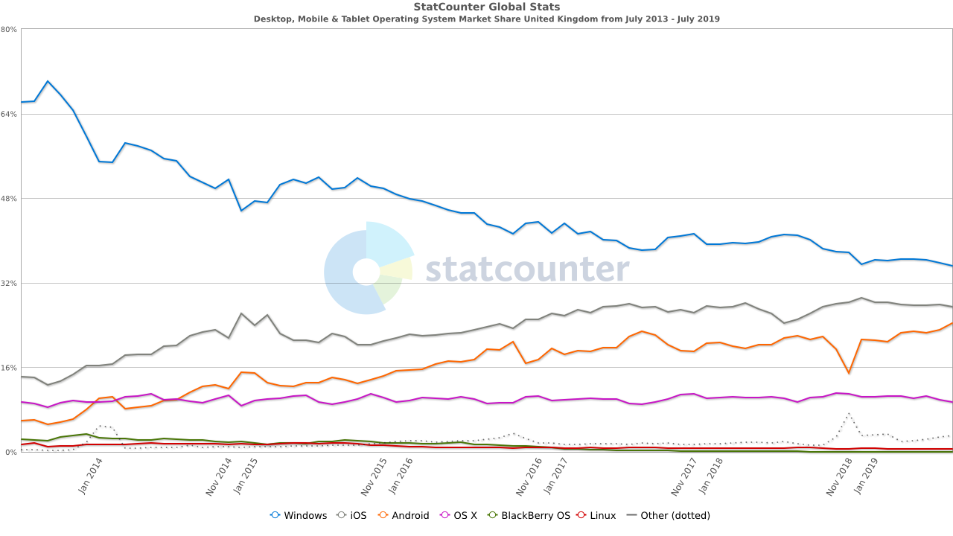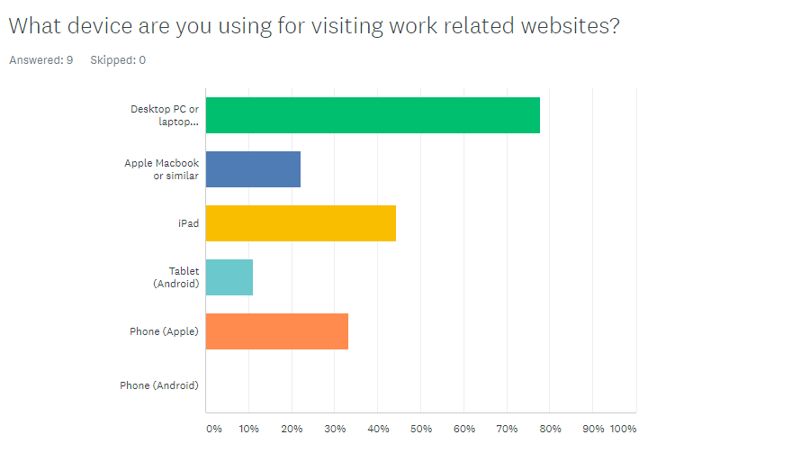

**Q1**

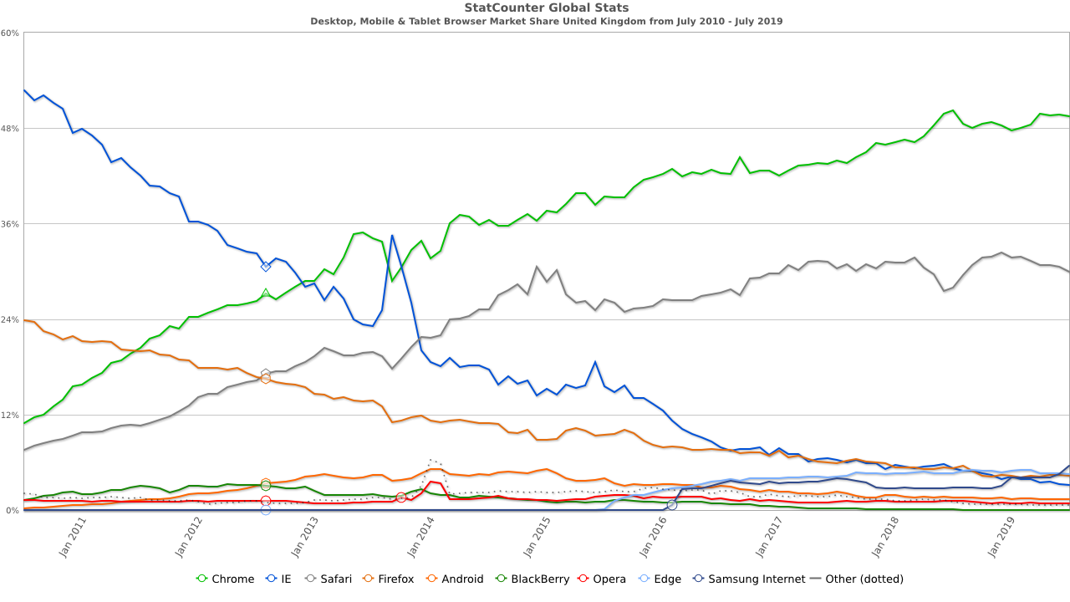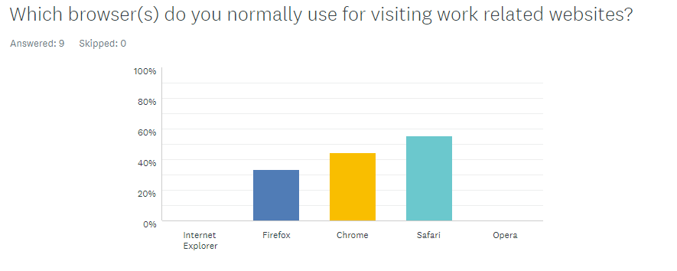

**Q2**

The following three questions focused more on the preference/personal opinion of the participants, to see what they think, after they have seen and tested the website prototype.

On Question 3, most of the respondents preferred to arrive on a landing page and see clear options to navigate. Question 4 was aimed at the comparison of single page and traditional multi-page sites trying to highlight the advantages of each in the options. The surveyees clearly knew each type of site and mostly opted for the multi-page or multi-page based ideas.

Question 6 investigates the importance of the individual features to the respondents. It is a central question since it has the potential to show, how these individuals think and see in a work-related situation. Personally, they might be interested in the colours or design a bit more, however professionally they do prefer to look at a content focused layout, readability and site efficiency.

These questions were necessary to be answered, as the trend is nowadays to just show the information on a single scrollable page without a traditional navbar. These professionals do not want to spend their time figuring out where they can find the required information about a possible applicant.

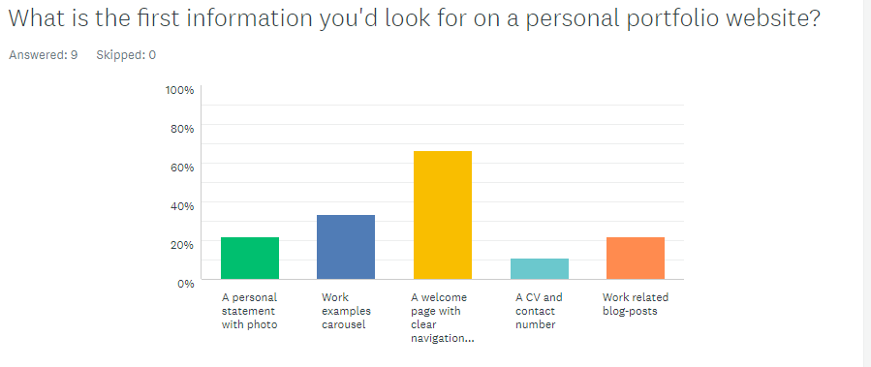

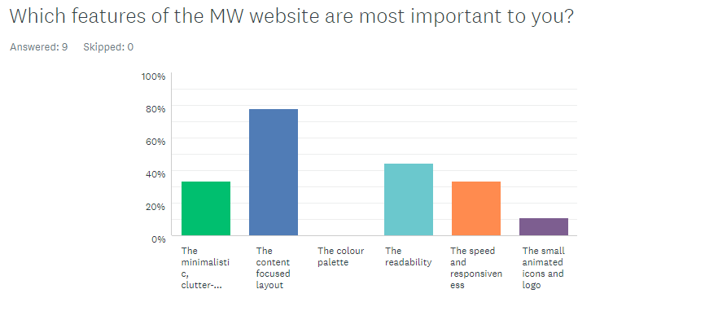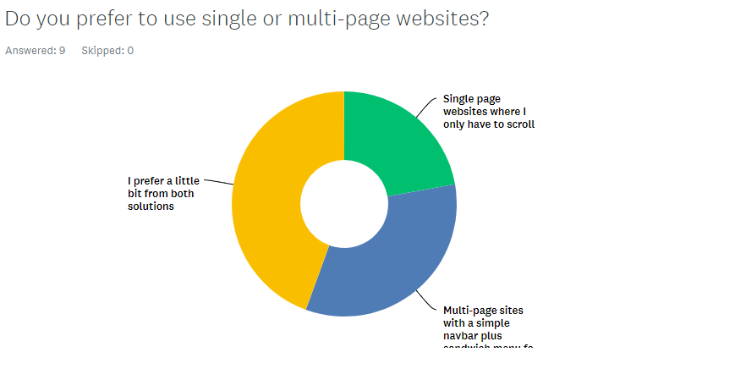

**Q6**

**Q3**

**Q4**

### Qualitative results

Question 5 and 7 were the two open-ended questions which can provide a different point of view, open up the insights these professionals gathered through their years of experience. By wording these questions so, that they imply that only a short answer is needed (*If you could change one thing, what comes to your mind* both imply a spontaneous first reaction rather than a long elaboration) gave self-confidence to the respondents not to skip these questions.

Q5 results shows several ideas we have considered with the client (social media integration, commenting under the posts) and contemplated if these options would be too much for a simplistic portfolio site or not. When my client saw these results, he changed his mind on the social integration and asked me to add LinkedIn sharing option but said no to the commenting, as it would cause him an unnecessary stress for him to please his audience.

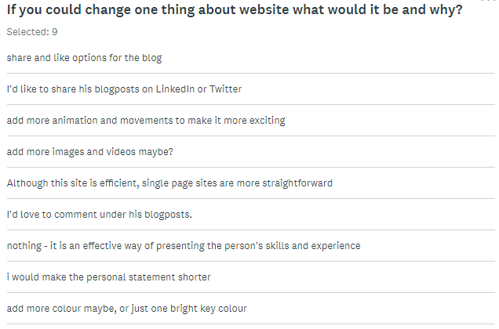

The rest of the answers were less constructive and logical, more like a first time thought, but some still useful and gave me the impression that there is still room to improve in the design and animation area.

Q7 is looking for a personal opinion and the answers are definitely worth to be considered. 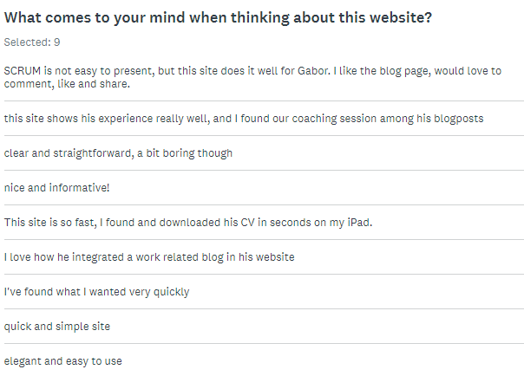

From the answers we can work out which profession wrote what – for example there were two SCRUM masters in the focus group, their answers are probably related to the blog, the recruitment professional mentioned the CV part, and the HR advisors wrote about the efficiency of the site. All in all, the feedbacks praise what these individuals think of importance – this result helped me to focus my attention to these areas.

# Technical details

## HTML code

### Site architecture and prototypes

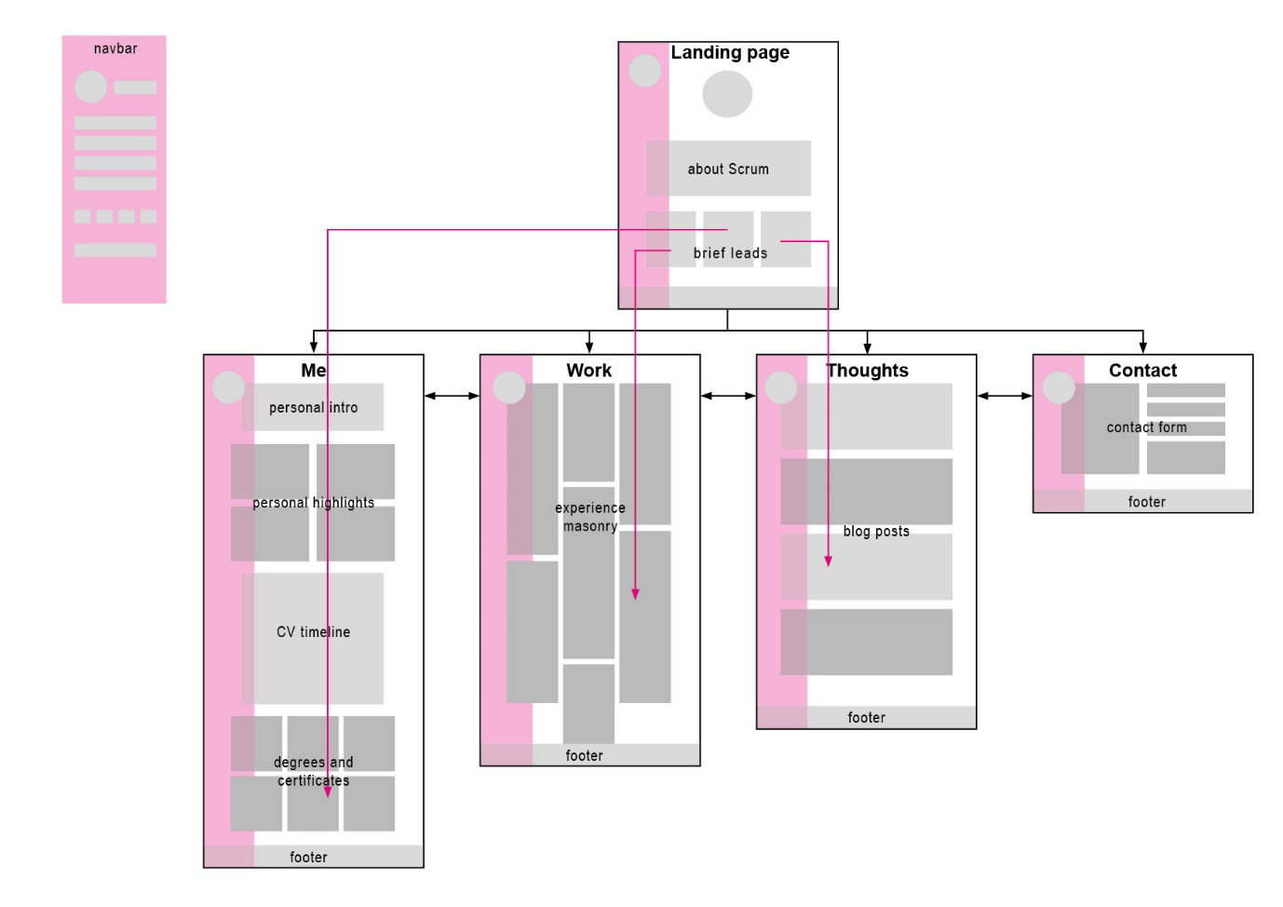

The site architecture as the figure above shows, is based on a standard hierarchy, starting on the landing page with the side navbar visible (on desktop), a short description of Scrum and some brief leads that link to certain topics on different pages. Every page is accessible via the side navbar, and a Download CV button is also provided for easy access. The decision whether to choose a single-page or a multi-page structure was made when I received the detailed client brief about the site and started creating the prototypes for desktop and mobile – the content was so diverse that a single-page scrollable design would have rendered the whole site too busy and confusing.

The XD prototypes on the following pages show the initial design concept (magenta for desktop and yellow for mobile) with a conventional top navbar and having mostly placeholder content. In the following sections I will describe what challenges shaped this initial concept into the final product.

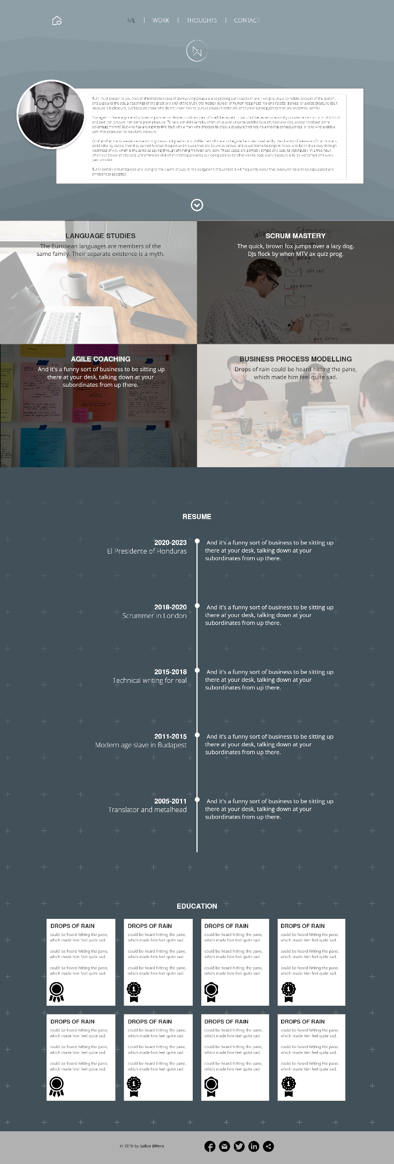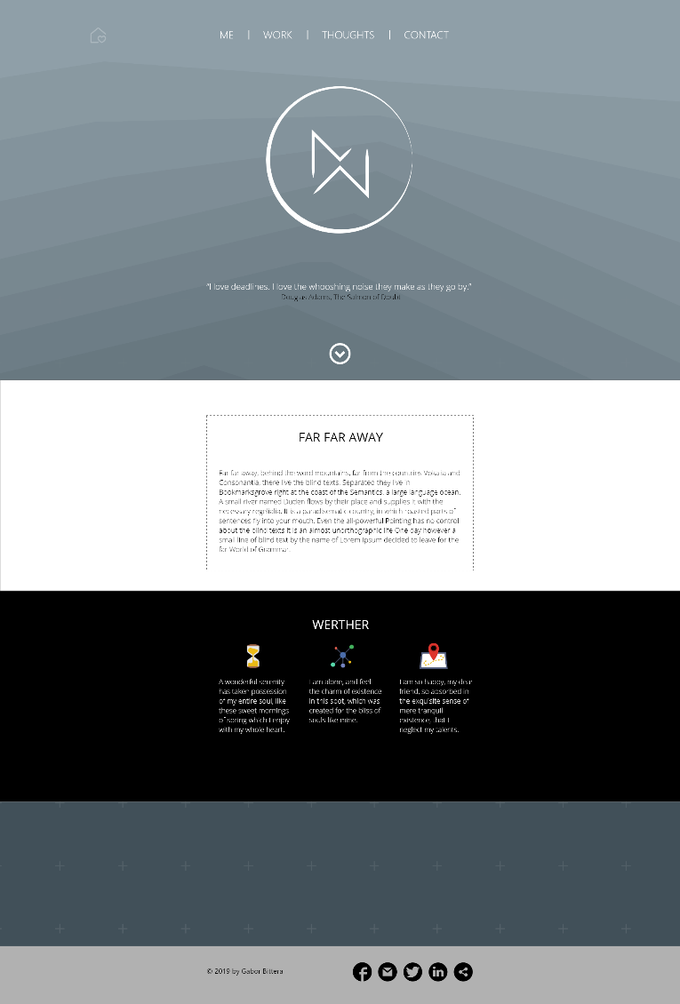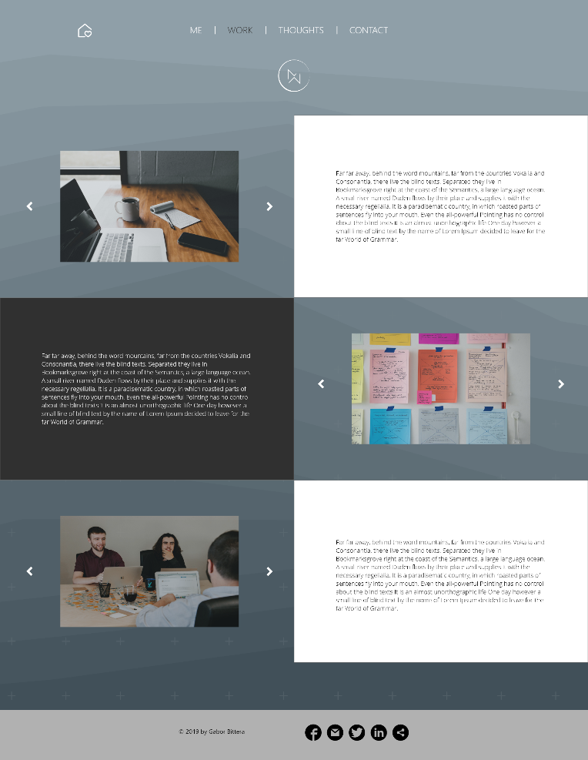

**Landing page**

**Works**

**Me**

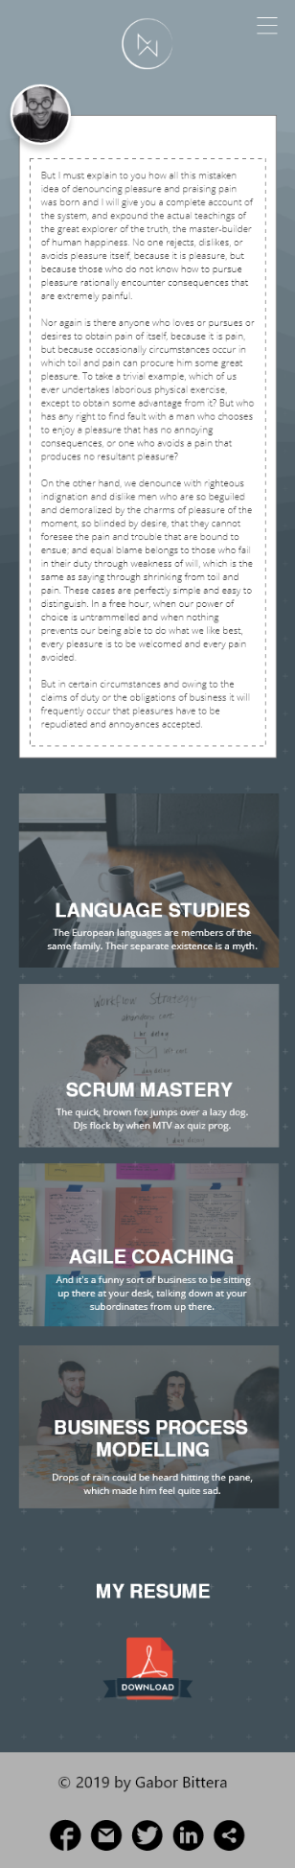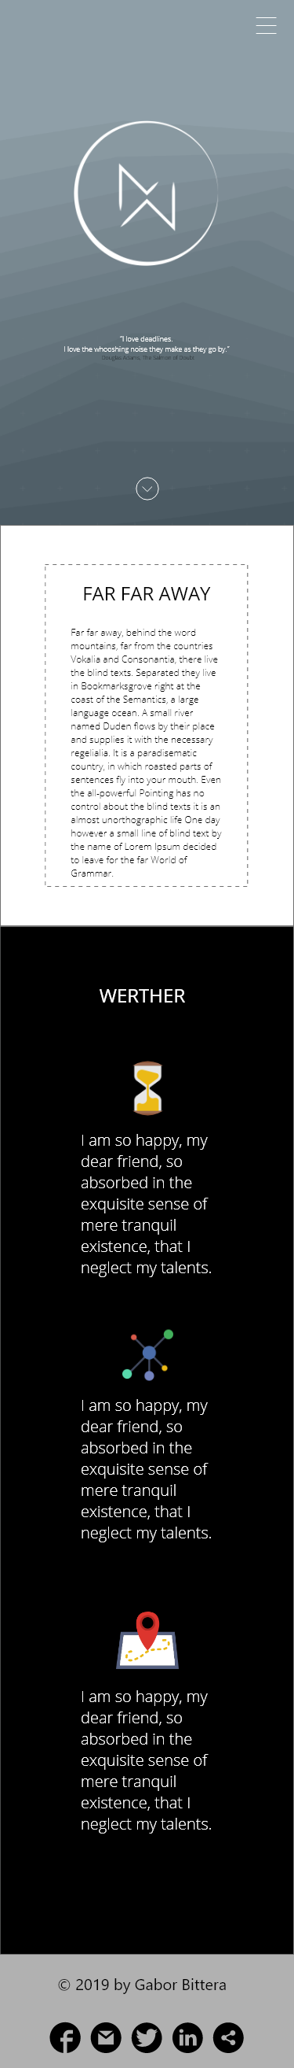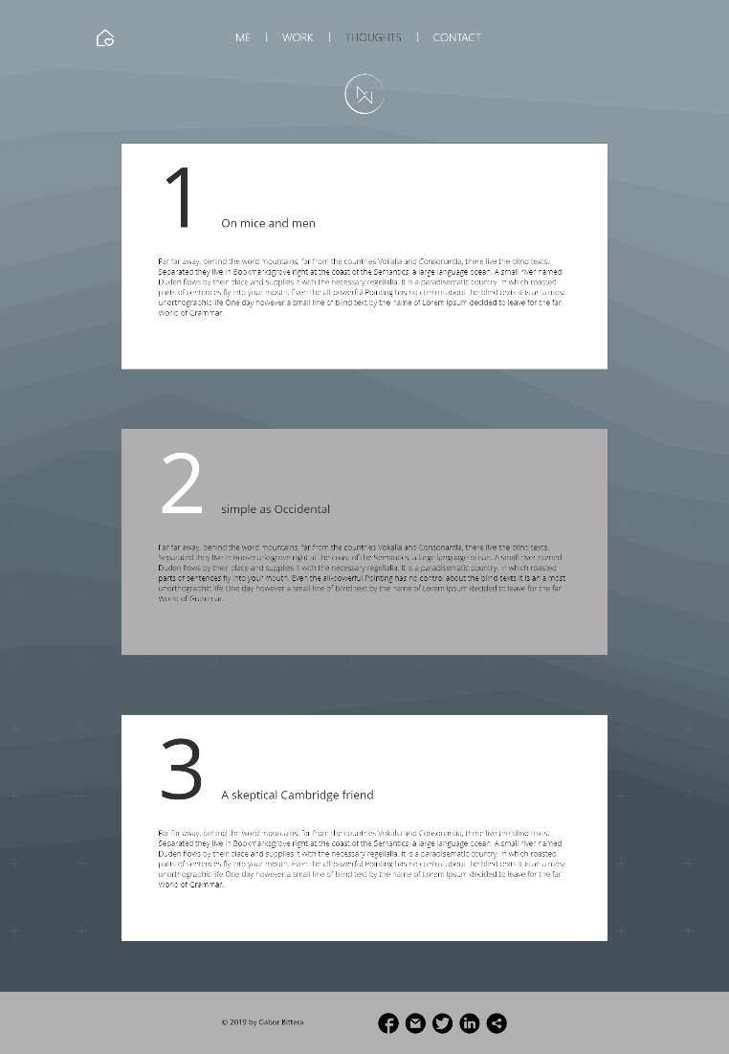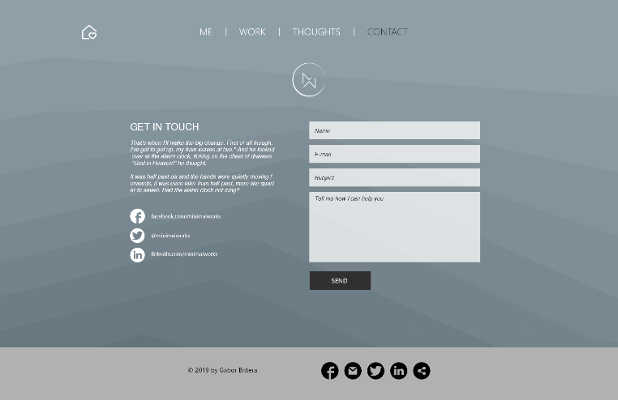

**Me**

**Landing page**

**Thoughts**

**Contact**

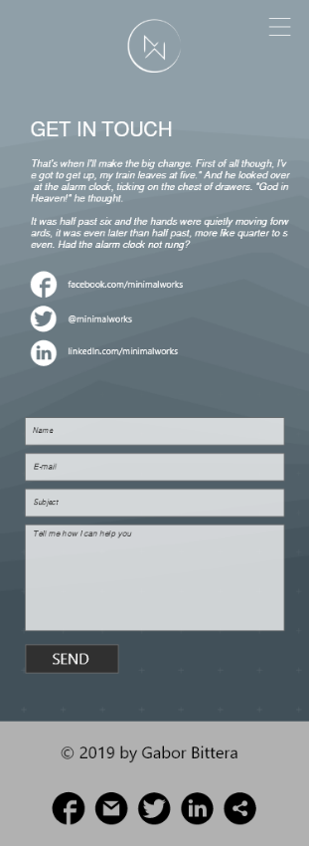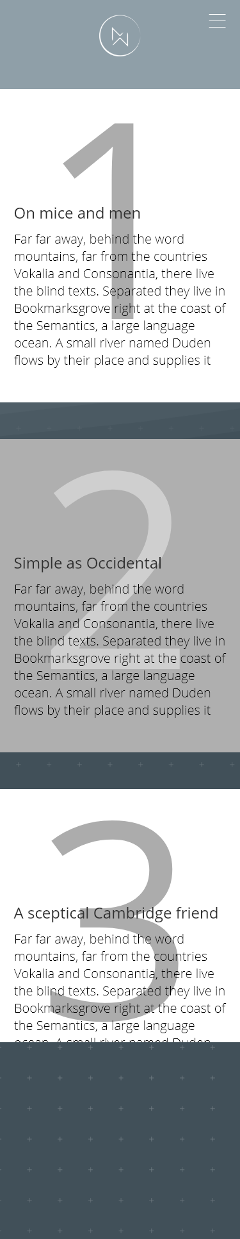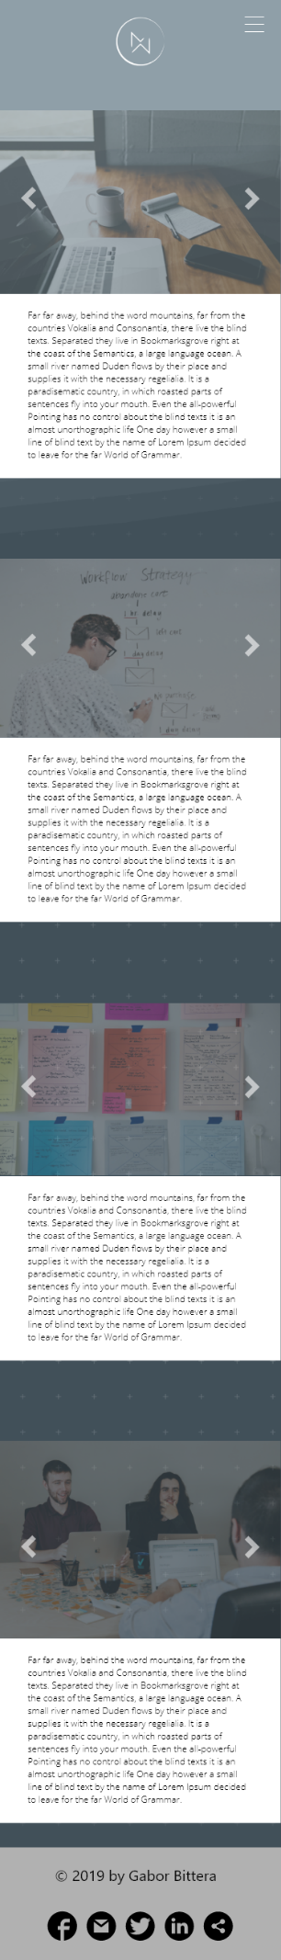

**Contact**

**Thoughts**

**Works**

### Design decisions

During the course of development, I had to make slight adjustments to the design, since the content I started with was not available initially. One of the more significant changes was adding an extra (key) colour to the default palette – this was requested several times by our target audience and confirmed by the client. The added colour made the whole site livelier and some important parts like the hamburger menu icon stand out more.

Works.html had to be redesigned as initially I expected a 50-50 ratio of images and content for my client’s work experience, but in reality, the projects were very text heavy and had to be presented in a different way. The image carousels that were already in the code had to be swapped to inline images and the layout needed to change to something flexible and easily extendable – a masonry layout. Thanks to Bootstrap, there was no need to utilise an external library for this, so I did not lose a lot of time with this change. The new layout is responsive, fast and does not have a swiping issue, as do the Bootstrap carousels on mobile.

Other minor design changes are the numbering on the blogposts, which are now subtle on every screen size, the simple white SVG icons on the landing page provide design consistency, and using dark grey instead of black makes the site less contrasty but still elegant.

### Navbar challenges

The conventional top navigation seemed like an appropriate choice for this minimalistic website, as it is easily usable by anyone and Bootstrap navbars has great features even for mobile screens. However, my client wanted to have a top-fixed navbar, which makes things a bit more complicated – especially in relation with the content when scrolled. The navbar became confusing, hardly legible when over an image or text. My first solution was a short JS code which gave the menu a solid background colour when scrolled.

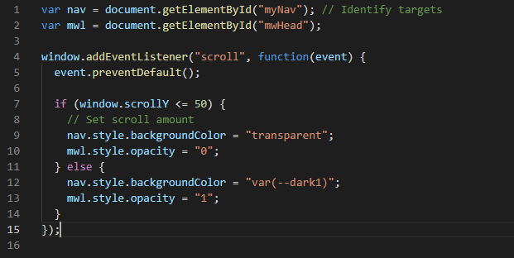

The code worked fine but raised some other challenges on mobile and also would have to set different scroll amount for each html page which did not seem viable, so I decided to go with a sidebar navigation option as it is quite popular on mobile and desktop too. After some research I chose the Bootstrap custom sidebar from Bootstrapious that provided the necessary flexibility the site required – on desktop size, the navbar is always on and very easy to use, provides a lot of space for adding extra navigation or downloadables in the future and is not interfering with the content.

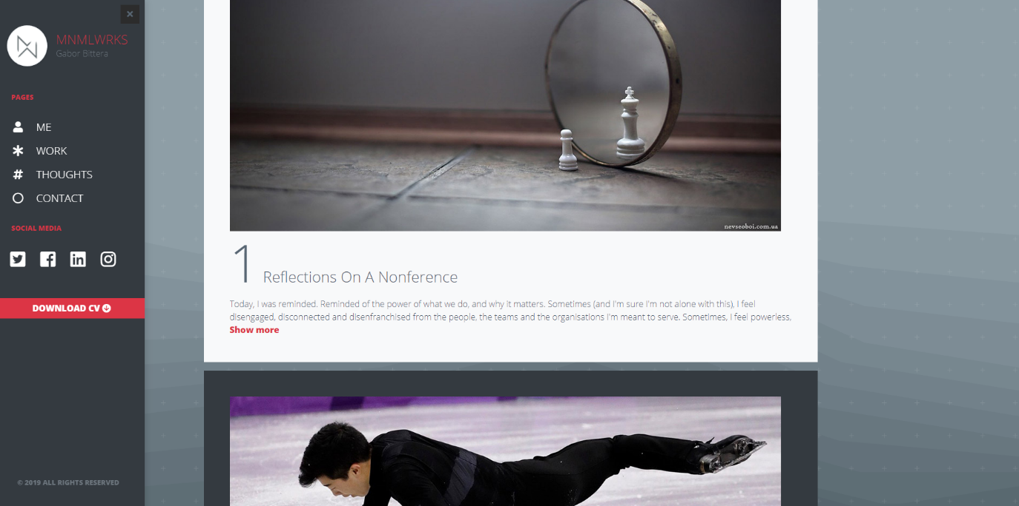

## CSS code

As earlier explained, Bootstrap CSS library is beneficial for several reasons – mainly for providing an extensive library of styling solutions for different devices and browsers. Using this library made my CSS code simple and clean – this was essential for my client who will want to make some changes later in the code. The preset classes work great and are also easily overwritten in my custom file, and there were only a few things that had to be created separated from this framework.

### Mobile styling challenges and solutions

My problems started with the :hover pseudo-class, which applies when the user points on an element with the mouse but does not click on it. Usually on mobile devices with a touch interface there is no pointing device, so these effects do not (really) work. I could not find a straightforward solution for this in the Bootstrap documentation, so I created a custom media query for devices with a screen-size width under 1024px and switched off the hover effects. It may not be the most elegant solution, but it is effective and saves some confusion for the user and some loading time for the mobile browser, which can be essential in some cases (e.g bad data coverage).

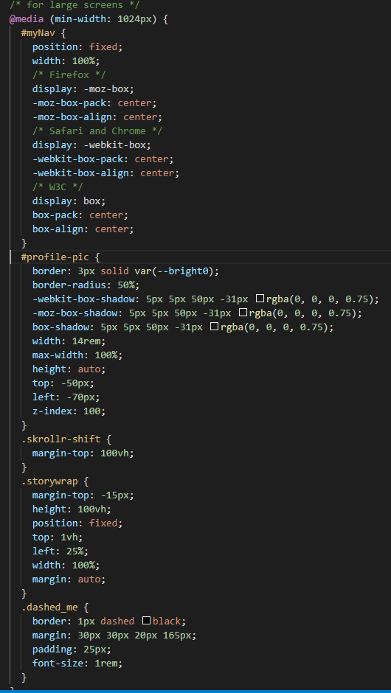Another media query had to be created for screens wider than 1024px, mainly for handling fixed and absolutely positioned objects on different layouts – this has been mostly successful; however, it is not perfect on every resolution and size – but works nicely on the most popular devices and browsers. The sidebar media query is just making sure that the navbar is the right size on smaller (<768px) screens.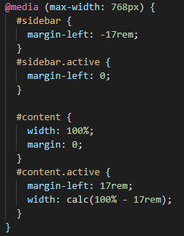

## JavaScript and PHP

Being one of the core technologies of the W3, JavaScript allows webpages to be changed dynamically and can add interactivity. Most of the websites live today are using some form of JS and it also a cross-browser language. For this project, I only planned to use two functions (show/hide & sidebar menu) to limit the number of problems, as mobile usage was very important for my client and most mobile browsers do not execute JS to save time and resources.

### Show & hide function

The blog feature my client needed on his website was not a complicated one, he simply wanted me to add articles without any commenting ability with a sharing option, if it is feasible. This JQuery function was altered from a StackOverflow one to suit our needs and it works great on mobile too – it is switching classes on the div named content making it from a 3em height div to full height and back.

### Challenges with the Skrollr library

The sidebar function has been explained earlier so I’ll continue with an additional function I decided to utilise – this is an external JS library called Skrollr which integrates scrolling effects and parallax functions – both were very much liked by my client. After reading the documentation I included the library script in my code, added the initiating script after that and inserted the required classes and data-values to the divs affected and all was working well, not on mobile devices, however. Even though the developers added an option to “fake” the scrolling touch on a phone or tablet, it was not perfect – so a condition had to be added around the library script to make sure, it is only loaded on a device with a screen size above 1024px.

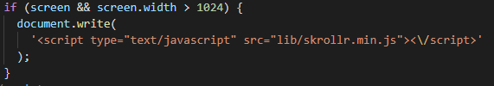

I wanted to use another feature of Skrollr, namely the SVG animation that is able to draw out a whole SVG in an interactive manner. My plan was to redraw the MW logo after a specific scroll value to a dark version of itself to make it more visible over the content. Despite all my efforts, this fell through and with the side navigation bar it became redundant as well.

### PHP

The contact page required two essential things – a standard forms markup, where resizing for different screens is controlled and validation is trustworthy, plus a PHP script can handle the email sending part of the action. I tried to find a different solution which does not involve a language I don’t know, but a mailto: option seemed very simple and I did not want to include an external website (like formspree or enformed.io), so I chose a tutorial to build a PHP contact script on Bootstrapious (PHP contact form help).

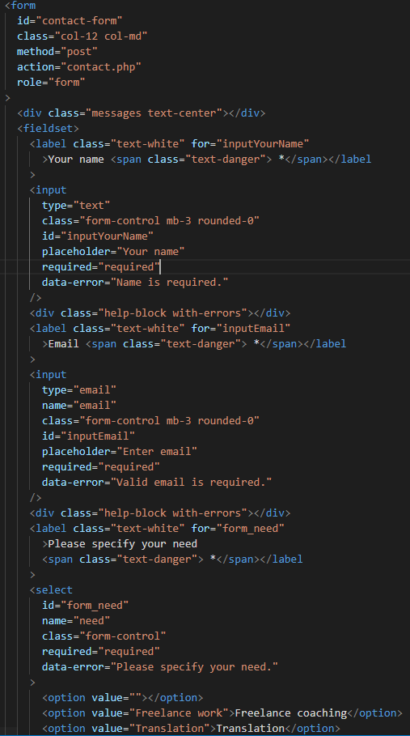With the form HTML code, I made sure that every field has a label with a ‘for’ attribute for accessibility reasons.

Bootstrap validation rules are a great option to use, this can make sure that all the ‘required’ values are there and correct. The type=”email” input also enhances the user experience, especially on mobiles.

# Findings and conclusion

## The client

In website design, the most important stakeholder is always the client. Their attitude towards the project defines how we can plan ahead, meet deadlines and develop ideas further and further. My client was an ideal first client – as he is a tech-savvy process management expert who understood not only the processes and timeframes I had to deal with, but the technical challenges and responsivity issues. His requirements were reasonable and technically considerate.

## Planning

The product backlog that we set up together on the first day contained the backbone of the project. Sprint backlogs were added later to set short-term goals for every week. This method is great for a team of developers, but for a single person, it was hard to keep up with it. I have learned that I do prefer the waterfall model when I work and plan, design, implement, and test sequentially.

## research

User research is one of my weaknesses especially with a website where the target audience is so specific. My email interview approach fell through with hardly any answers but with my client’s help I managed to collect people willing to answer a short questionnaire. They have seen and tested my prototype but I did not have the chance to further tests on the finished product. On my next projects I will definitely leave more time for user research and allow extra test opportunities as well.

## technical findings

Full responsivity is very hard to achieve and it also demands continuous development and maintenance of the website as devices, resolutions and browsers are constantly changing. I have face numerous challenges because the resource I wanted to use was out of date or obsolete. Thankfully Bootstrap is a well-managed library with lots of users so it was easier to solve problems, some JS libraries (Skrollr) however required a lot more work and caused more delay than I expected. I also wanted to experiment with SVG animation and social (LinkedIn) sharing methods but after spending lots of time on these, I could not make them work with the design and other functionality. These are two development opportunities for the next iteration, as my client requested to have these on the site.

## Conclusion

My client is very satisfied with the first iteration results, well impressed with the site design and performance on mobile devices. This is something I wanted to achieve; however, I do realise that the site has shortcomings and a lot of room to be improved in the future. I have learned that it is a great challenge to connect the design with the functionality to create a web-product that is usable and accessible and having a tech-savvy client can make our lives a lot easier. In this case, the client was supportive, knowledgeable and did not have any unreasonable or unnecessary requests. His process management experience provided a great backbone for the whole project which guided me through the development process.

# Appendix

## Website links

<http://ahuszk01.vdwp1819.bbkweb.org/final>

<https://github.com/GiacomoSorbi/ahuszk01>

<https://giacomosorbi.github.io/ahuszk01/>

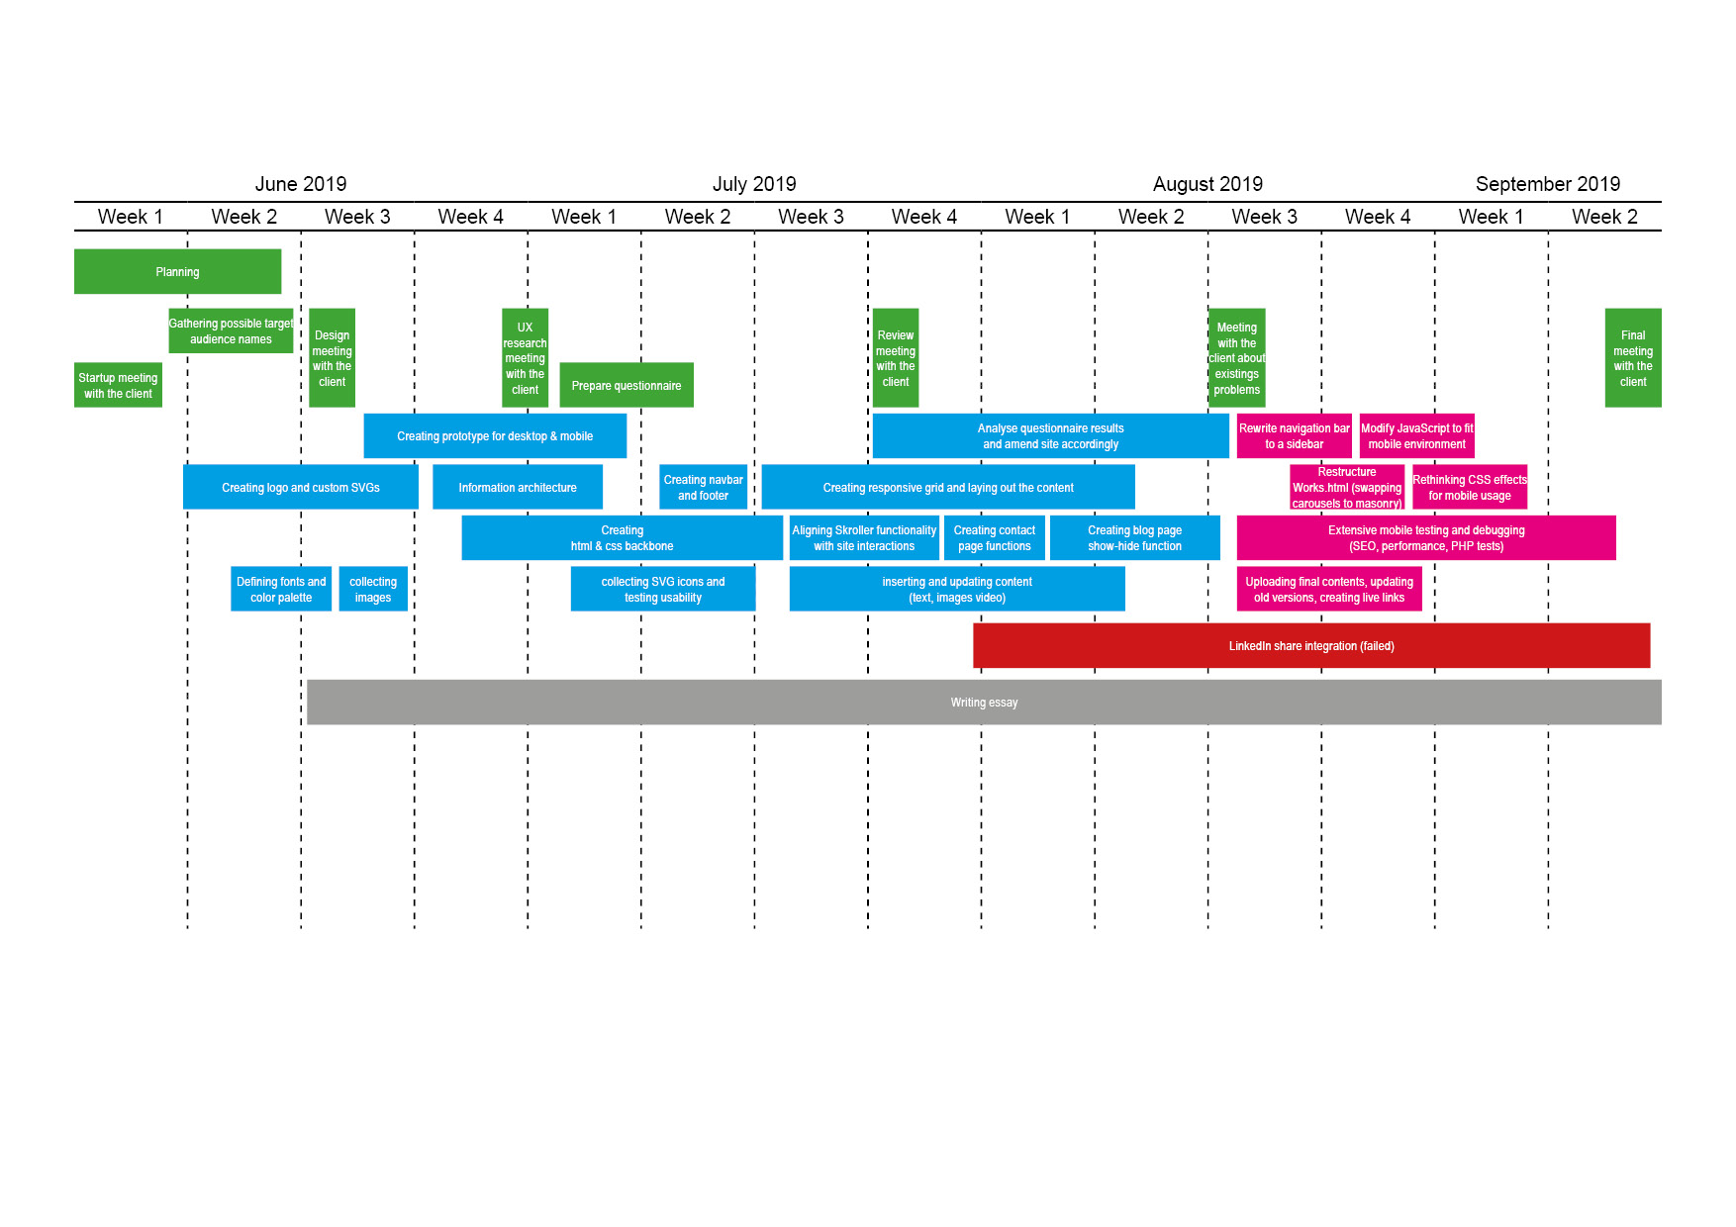

## Questionnaire link

<https://www.surveymonkey.com/results/SM-NWSG66KJ7/>

## Project plan

## Product backlog

# References

Ethan Marcotte, Responsive Web Design, 2010,   
<https://alistapart.com/article/responsive-web-design/>

Masha Fish, Mobile-friendly sites turn visitors into customers, 2012  
<http://googlemobileads.blogspot.com/2012/09/mobile-friendly-sites-turn-visitors.html>

Frederic Gonzalo, Understanding the difference between mobile-first, adaptive and responsive design, 2017  
<https://fredericgonzalo.com/en/2017/03/01/understanding-the-difference-between-mobile-first-adaptive-and-responsive-design/>

Nilesh Jain, Review of different responsive CSS front-end frameworks, 2014  
<http://www.jgrcs.info/index.php/jgrcs/article/viewFile/949/607>

Jake Giltsoff, SVG ON THE WEB - A Practical Guide, 2015  
[https://svgontheweb.com](https://svgontheweb.com/)

Antoine Quint, Scalable Vector Graphics, 2003  
<https://ieeexplore.ieee.org/stamp/stamp.jsp?tp=&arnumber=1218261>

Kujala Sari, "User involvement: a review of the benefits and challenges," Behaviour and Information Technology, 2003  
<https://www.researchgate.net/publication/220208710_User_involvement_A_review_of_the_benefits_and_challenges>

Clay Spinuzzi, The methodology of participatory design, 2005  
<https://repositories.lib.utexas.edu/bitstream/handle/2152/28277/SpinuzziTheMethodologyOfParticipatoryDesign.pdf>

<https://gs.statcounter.com/browser-market-share/desktop-mobile-tablet/united-kingdom/#monthly-201007-201907>

Sidebar help - <https://bootstrapious.com/p/bootstrap-sidebar>

[Show-hide function help - javascript - How to create a "show more" button and specify how many lines of text can be initially shown - Stack Overflow](https://stackoverflow.com/questions/12307666/how-to-create-a-show-more-button-and-specify-how-many-lines-of-text-can-be-ini)

Skrollr external JS library - [skrollr/classic.html at master · Prinzhorn/skrollr](https://github.com/Prinzhorn/skrollr/blob/master/examples/classic.html)

Icons - [Search results for Social - Flaticon](https://www.flaticon.com/search?word=social&order_by=1&color=1)

PHP contact form help - [A Working Bootstrap HTML Contact Form - Step-by-Step Tutorial](https://bootstrapious.com/p/how-to-build-a-working-bootstrap-contact-form)

[javascript - Changing nav-bar color after scrolling? - Stack Overflow](https://stackoverflow.com/questions/23706003/changing-nav-bar-color-after-scrolling)